Game – analysis

**Sky: Children of the Light**

“A social adventure game focusing on cooperative exploration and emotional connection”

Platform: Mobile / PC / Console (Android, iOS, Switch, PlayStation, PC)

User group: All ages

Genre: Adventure / Art / Graphic game

Mechanics: Gathering resources (light energy, candles, spirits/expressions), flying, light manipulation and helping spirits.

Dynamics: Cooperative exploration + problem-solving and emotional connection

Aesthetics: Fellowship, Expression, and Fantasy through cooperative exploration. Created by ethereal visuals and atmospheric sound design

UI controls: 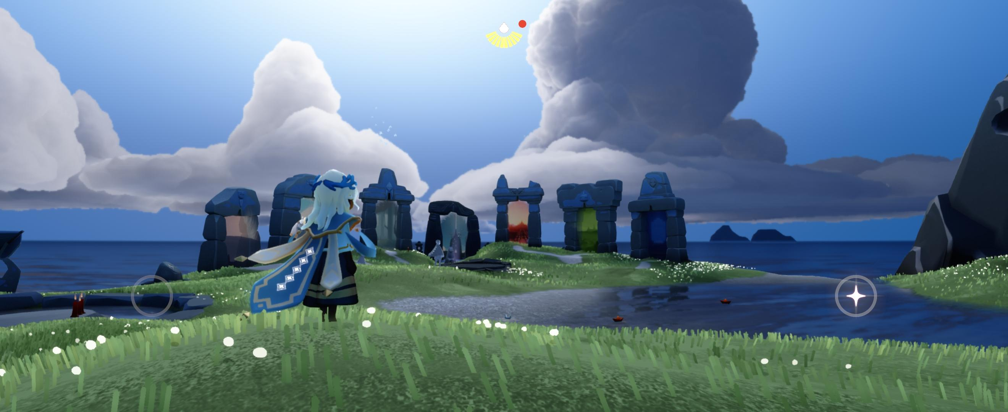

Above image shows a screenshot of the game. Left circle is the joystick (this controls movement), if you hold it, it expands to make it easier for the user to walk. Right circle with the star is the jump button. If you hold it, you start to fly. Actions are done by just tapping things when you are close.

Dark patterns: [DarkPattern.games » 'Sky: Children of the Light' Rating](https://www.darkpattern.games/game/6266/0/sky-children-of-the-light.html)

Red/bad rating for: Temporal dark patterns.

Black/neutral rating for: Monetary, Social and Psychological dark patterns.

Green/healthy rating for: N/A

**Minecraft**

“A sandbox survival game emphasizing creativity and exploration”

Platform: Mobile / PC / Console

User group: All ages

Genre: Sandbox

Mechanics: Gathering resources (items, consumables, blocks), building, mining and crafting

Dynamics: Creative building and survival

Aesthetics: Discovery, Fantasy, and Expression through creative building. Created by block-based visuals with creative freedom

UI controls: 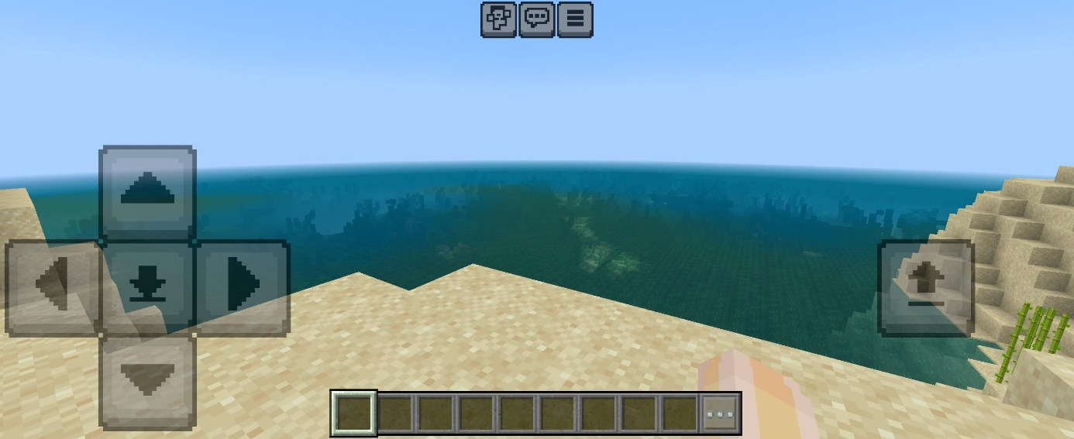

Above image shows a screenshot of the game. Left are the movement controls. The square in the middle (with the arrow pointing down) is crouch. Right is the jump button. Tap twice to fly in creative mode. Blocks are placed by tapping the location where you want to put it and breaking blocks is done by pressing and holding the block you want to break.

Dark patterns: [DarkPattern.games » 'Minecraft' Rating](https://www.darkpattern.games/game/101/0/minecraft.html)

Red/bad rating for: N/A

Black/Neutral rating for: Psychological dark patterns.

Green/healthy rating for: Temporal, Monetary and Social dark patterns.

**Bullet Echo!**

“A stealth action game featuring competitive multiplayer”

Platform: Mobile

User group: 16 and up

Genre: Action

Mechanics: Gathering resources (ammunition, armour, movement points, coins), movement, stealth and sound detection

Dynamics: Strategic stealth and competitive play

Aesthetics: Competition, Challenge, and Sensation through stealth gameplay. Created by minimalist visuals with emphasis on sound

UI controls:

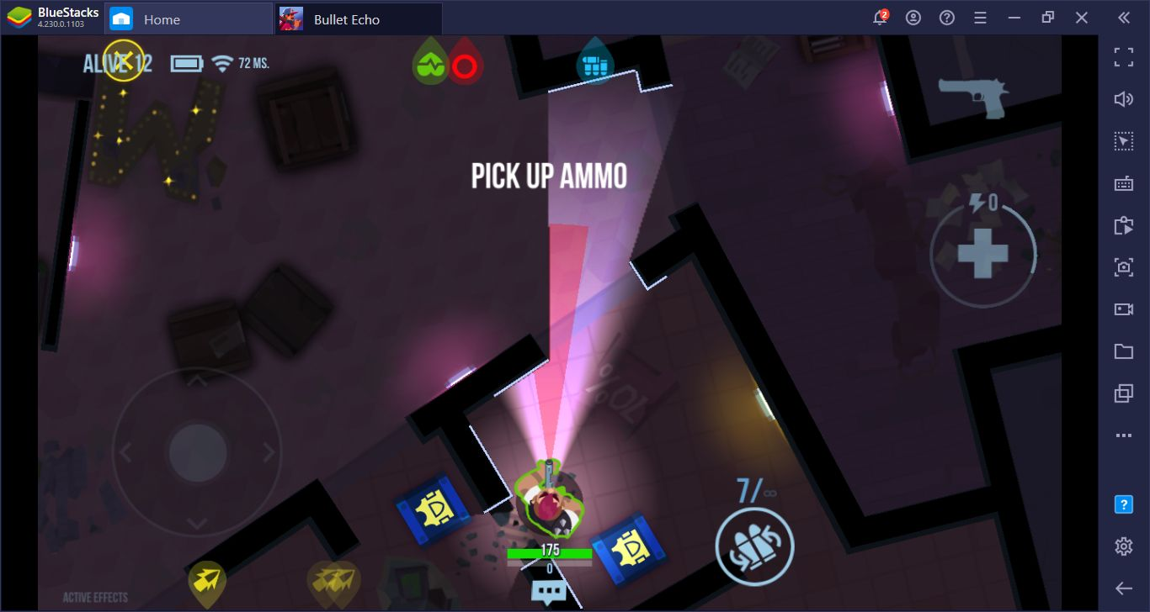

Above image shows a screenshot of the game. Left circle is the joystick (this controls movement), if you hold it, it expands to make it easier for the user to walk. To turn, swipe on the right side of the screen. Powers are activated by tapping the circles. Shooting and picking up items are done automatically (picking stuff up require you to stand still).

Dark patterns: [DarkPattern.games » 'Bullet Echo!' Rating](https://www.darkpattern.games/game/20828/0/bullet-echo-.html)

Red/bad rating for: Temporal, Monetary and Psychological dark patterns.

Black/Neutral rating for: Social dark patterns.

Green/healthy rating for: N/A

**Driftmoon**

“An action RPG with emphasis on storytelling and exploration”

Platform: Mobile / PC

User group: 9 and up

Genre: Adventure

Mechanics: Gathering resources (health, mana, inventory items), combat, exploration and character progression

Dynamics: Story-driven exploration and combat

Aesthetics: Fantasy, Narrative, and Discovery through RPG elements. Created by colourful RPG aesthetic with narrative focus

UI controls: 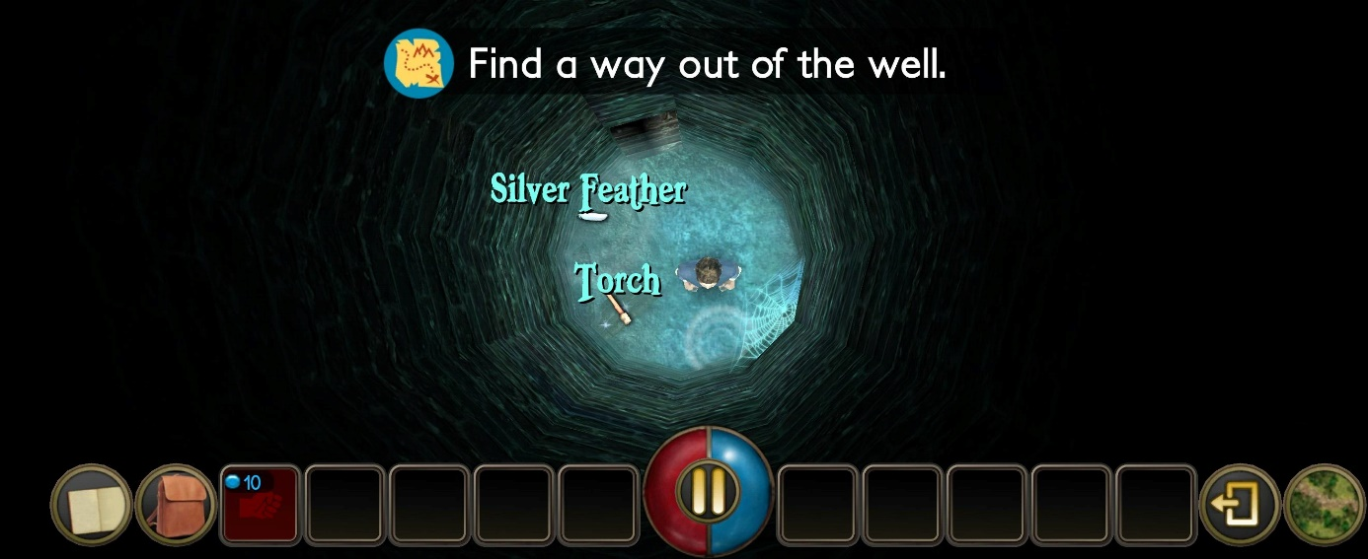

Above image shows a screenshot of the game. Walking around is done by placing and holding your finger somewhere on the screen (unless on a UI element). The character is essentially the centre of the joystick. Picking up items is done by pressing them. Combat is done automatically when you tap on an enemy.

Dark patterns: N/A

**Darkwood**

“A top-down survival horror game with focus on atmosphere and exploration”

Platform: PC / Console

User group: Young adults and above

Genre: top-down survival horror game

Mechanics: Time / Light / Night events / Essence / Health and Stamina / Reputation / Status Effects

Dynamics: Forcing auto-save / Managing storage space / Refuelling the generator and table saw / Charge-attack and quick swing with a melee weapon / Dodging attacks / Activating skills / Scavenging and gearing-up / Setting up the hideout

Aesthetics: Fear, Challenge, and Discovery through survival horror. Created by atmospheric horror visuals and sound design

Controls: You can choose to control the character between 2 different styles; Either relative or non-relative. With the non-relative control style, using the WASD keys of the keyboard will make the character move in absolute directions regardless of where the player is currently looking with the mouse. With the relative control style, using the WASD keys of the keyboard will make the character move in relation to where the player is currently looking with the mouse.

Dark patterns: N/A